TAURUS MANAGEMENT AND INVESTMENTS LTD.
Company No. 514565118
25 Benjamin Movshovitz St.
Herzliya 4640525
Israel
SOLE SHAREHOLDER RESOLUTION
Date: June 4, 2026
I, Amichai Krupik, being the sole shareholder of TAURUS MANAGEMENT AND INVESTMENTS LTD., hereby adopt the following resolutions:
RESOLVED THAT:
- The Company shall establish a Wyoming Limited Liability Company under the name: VIGMIS US LLC
- TAURUS MANAGEMENT AND INVESTMENTS LTD. shall be the sole member and one hundred percent (100%) owner of VIGMIS US LLC.
- VIGMIS US LLC shall engage in sales, marketing, customer acquisition, billing, payment processing, subscription management and related commercial activities in connection with the VIGMIS platform and associated services.
- The intellectual property, software, technology, trademarks, know-how, websites and all proprietary rights relating to VIGMIS shall remain the property of TAURUS MANAGEMENT AND INVESTMENTS LTD., unless otherwise agreed in writing.
- The sole director of the Company is authorized to execute all documents and take all actions required for:
  - Formation of VIGMIS US LLC;
  - Appointment of a Registered Agent;
  - Obtaining an Employer Identification Number (EIN) from the Internal Revenue Service (IRS);
  - Opening bank accounts;
  - Opening and operating Stripe and other payment processing accounts;
  - Entering into agreements necessary for the operation of VIGMIS US LLC.
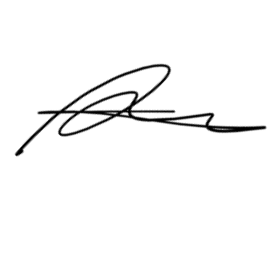
- Any actions previously taken in connection with the foregoing matters are hereby approved, confirmed and ratified.
Executed on the date first written above.

Amichai Krupik
Shareholder
TAURUS MANAGEMENT AND INVESTMENTS LTD.

TAURUS MANAGEMENT AND INVESTMENTS LTD.
Company No. 514565118
25 Benjamin Movshovitz St.
Herzliya 4640525
Israel
SOLE DIRECTOR RESOLUTION
Date: June 4, 2026
I, Amichai Krupik, being the sole director of TAURUS MANAGEMENT AND INVESTMENTS LTD., hereby adopt the following resolutions:
RESOLVED THAT:
- The Company shall establish a Wyoming Limited Liability Company under the name: VIGMIS US LLC
- TAURUS MANAGEMENT AND INVESTMENTS LTD. shall be the sole member and owner of VIGMIS US LLC.
- VIGMIS US LLC shall operate as the sales, marketing, billing, customer acquisition and payment processing entity for the VIGMIS business.
- TAURUS MANAGEMENT AND INVESTMENTS LTD. shall continue to own and control the VIGMIS intellectual property, software, technology, trademarks, websites and related assets.
- The undersigned is authorized to:
  - Sign Articles of Organization and related formation documents;
  - Obtain an EIN from the IRS;
  - Open and operate business bank accounts;
  - Open and operate Stripe, payment processing and merchant accounts;
  - Execute agreements required for the operation of VIGMIS US LLC;
  - Execute intercompany agreements between TAURUS MANAGEMENT AND INVESTMENTS LTD. and VIGMIS US LLC.

- All actions previously taken in connection with the foregoing matters are hereby approved, confirmed and ratified.
Executed on the date first written above.

Amichai Krupik
Sole Director
TAURUS MANAGEMENT AND INVESTMENTS LTD.

